Strategy Gartner MQ 2026 Blog

Strategy Named as a Visionary in the 2026 Gartner® Magic Quadrant™ for Analytics and Business Intelligence Platforms
In our view, Strategy’s Visionary placement reflects a broader shift toward AI-ready analytics and governed business context.
Quick Answer
AI-ready analytics needs more than dashboards and data access. It needs governed business context that BI tools, applications, and AI agents can reuse consistently.
Strategy has been positioned as a Visionary in the 2026 Gartner® Magic Quadrant™ for Analytics and Business Intelligence Platforms. In our view, this recognition aligns with a broader market shift toward platforms that can define, govern, and reuse business logic across people, applications, and AI agents.

Why This Gartner Recognition Matters to Us Now
The significance of the 2026 Gartner® Magic Quadrant™ is not only Strategy’s Visionary placement. In our view, it also reflects a broader shift in how the analytics and BI market is evolving.
Analytics and BI platforms are no longer being defined only by dashboards, reports, and self-service analysis. The market conversation is moving toward agentic AI, governed semantics, and AI-augmented decision support. That changes the buyer question.
The era of duplicating business logic across every tool is ending. Enterprises cannot keep redefining metrics inside each dashboard, application, AI assistant, and data platform. That path creates metric drift at AI scale.

Why Governed Context Matters for AI-Ready Analytics
AI does not just need access to enterprise data. It needs to understand what the business means by that data: which revenue definition is approved, which customer population counts, and which hierarchy, permission, time period, or relationship should shape the answer.
In BI, those differences create reconciliation work. In agentic analytics, they can move directly into recommendations, workflows, and customer-facing actions. Dashboards exposed inconsistent definitions. AI agents can operationalize them. Closing that gap requires more than connecting an LLM to a warehouse, lakehouse, dashboard, or catalog. It requires business context that travels with every query, workflow, and agent interaction.
That is the role Strategy Mosaic is built to play: a governed universal semantic layer where metrics, relationships, permissions, and business logic can be defined once and reused across tools. AI agents do not replace dashboards, reports, or existing analytics investments. They make reusable business meaning more important because every new AI workflow needs the same trusted foundation.

How We Believe Strategy Mosaic Supports This Shift
In our view, the practical enterprise question is clear: how can AI use analytics without rebuilding logic or weakening governance?
- Universal semantic layer. Define metrics and business logic once, then reuse them across BI tools, applications, embedded analytics, and AI agents.
- Governed AI access. Give AI tools approved metrics and semantic definitions without exposing agents to raw schemas. MCP support is in preview, with APIs for other workflows.
- Faster, cleaner modeling. Model business logic with flexible joins, custom calendars, business-friendly naming, AI-assisted controls, and Databricks Unity Catalog metadata integration.
- Open semantic reuse. Use APIs and standards-oriented work, including participation in Open Semantic Interchange, to carry trusted definitions across data sources, BI tools, applications, and AI platforms.
- Operational visibility. Monitor access, governance, anomalies, and cost with Mosaic Sentinel and Sentinel Cost Intelligence as usage grows.

Strategy Mosaic acts as the semantic control plane between enterprise data sources and downstream experiences, from dashboards and embedded analytics to AI assistants and operational workflows. Data stays where it lives. Business meaning stops being rebuilt in every tool.

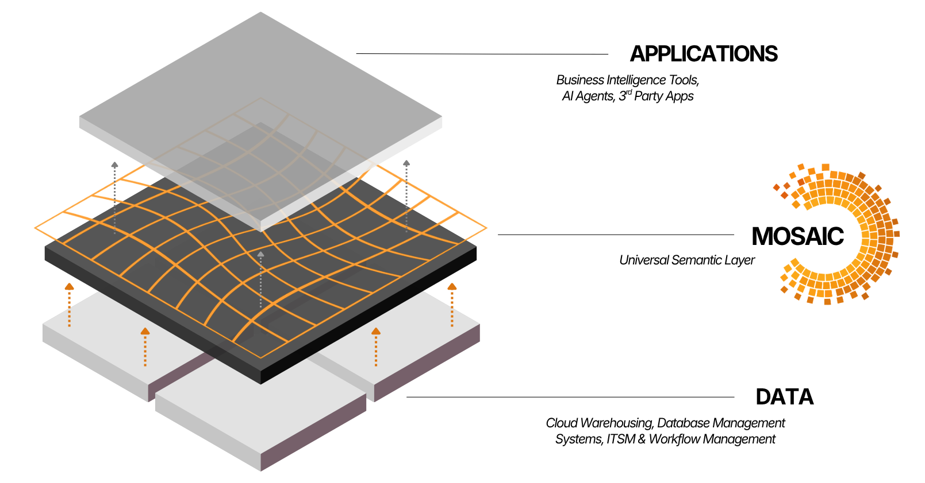
Figure: Strategy Mosaic connects enterprise data infrastructure to downstream decision experiences through a universal semantic layer.
This is the practical answer: business context is governed once, then carried consistently into every query, workflow, and AI interaction.

What Comes Next for Strategy
The next phase of AI-ready analytics is not about adding more disconnected AI features. It is about making business meaning reusable, governed, and available across the full decision lifecycle.
That is where Strategy Mosaic is headed: richer business concepts, reusable relationships, stronger governance, broader AI access, and deeper visibility through Mosaic Sentinel. The goal is simple: help enterprises move faster without rebuilding logic, losing trust, or giving up control as AI usage scales.

FAQ: Strategy Mosaic, Gartner MQ, and AI-Ready Analytics

Why does governed context matter more as analytics becomes AI-enabled?
AI-enabled tools can summarize, recommend, trigger workflows, and guide decisions, not just display answers. That makes trusted context operationally important: the same question should not produce different answers across tools, teams, or agents.

Why is Strategy Mosaic central to this positioning?
Mosaic provides the semantic foundation that connects BI, embedded analytics, applications, and AI agents to consistent business context. It helps analytics and AI use the same trusted metrics, relationships, permissions, and policies rather than rebuilding logic in each tool.

What role does MCP play in the Strategy Mosaic story?
Model Context Protocol support gives AI agents a more standardized path to approved semantic definitions and metrics. Rather than exposing agents directly to raw schemas, Mosaic can provide business-ready context with inherited governance and access controls. Mosaic MCP support is currently in preview, with broader availability planned for a future release.

How does Strategy handle governance as AI usage scales?
Mosaic Sentinel centralizes governance, monitoring, and auditability across governed semantic access and AI-driven analytics activity. Sentinel Cost Intelligence also helps connect analytics usage and spend back to governed assets so cost becomes part of the governance conversation.

Go Deeper
Ready to build AI-ready analytics on governed business context? Request a Mosaic Demo
- Download the Semantic Layer Buyer's Guide
- Learn more about Strategy Mosaic

Attribution and Legal Disclaimers
Gartner, Magic Quadrant for Analytics and Business Intelligence Platforms, Anirudh Ganeshan, Christopher Long, Edgar Macari, 29 June 2026. Gartner® and Magic Quadrant™ are trademarks of Gartner Inc. and/or its affiliates. Gartner does not endorse any vendor, product or service depicted in its research publications, and does not advise technology users to select only those vendors with the highest ratings or other designation. Gartner research publications consist of the opinions of Gartner's business and technology insights organization and should not be construed as statements of fact. Gartner disclaims all warranties, expressed or implied, with respect to this research, including any warranties of merchantability or fitness for a particular purpose.

